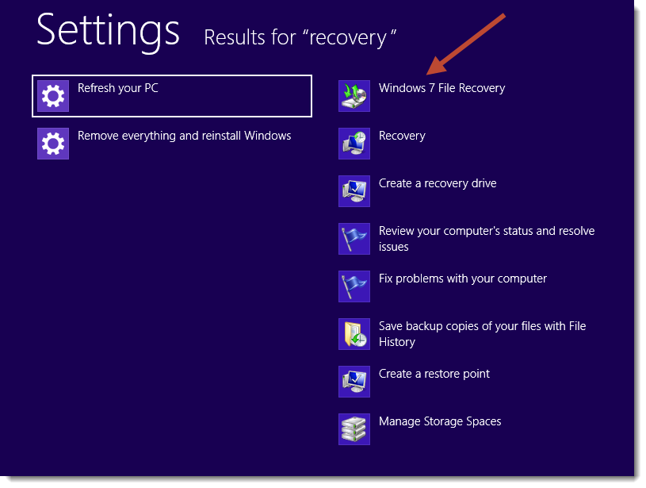
To create a system image in Windows 8, here's what you need to do:
Step 1: Search for "recovery" from the Windows 8 Start screen, then select the setting, "Windows 7 File Recovery."

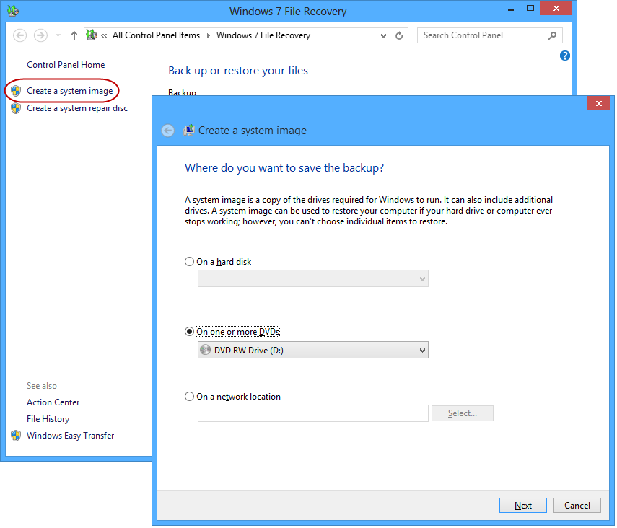
Step 2: Once the windows 7 File Recovery control panel launches, click on the "Create a system image" link from the left side of the window.
Step 3: Choose where you want to save the system image. You can select an external storage device or burn the image to DVDs. An External hard drive would be preferable here, since a system image can be several gigabytes or more.

Step 4: Confirm that the backup settings look correct, then click the Start backup button.
At the end of the process, you'll have the option to create a system repair disc or create a USB recovery drive instead. You can skip it. Not required.
