In the Outlook client, click File.
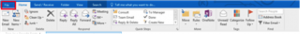
Open & Export > Import/Export
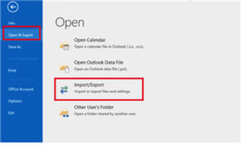
Choose Export to a file > Next
Choose Comma Separated Values > Next.
Choose the Contacts folder > Next.
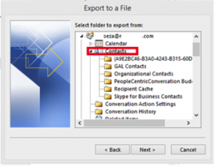
Choose a location to save this CSV file > Next > Finish.
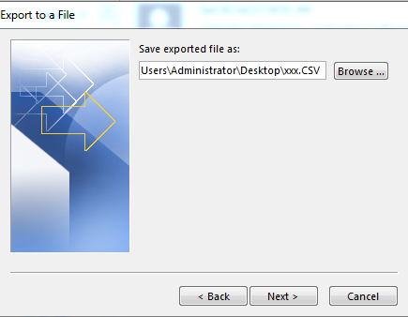then next
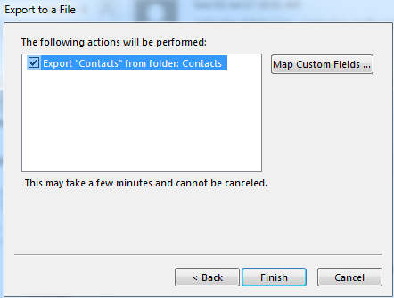then finish.
You will get CSV. File as destination folder.

