1. Download, install and launch EaseUS Partition Master.
2. Right click the partition that you want to carve up free space for the C: drive on the disk map, and choose "Resize/Move partition".
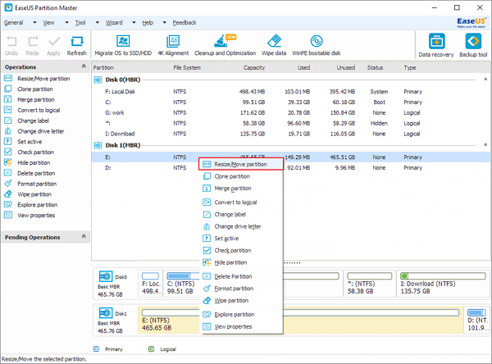
3. Position the mouse pointer on the left partition handle. Drag the handle to the partition size you want when the mouse pointer changes to a double-headed arrow.
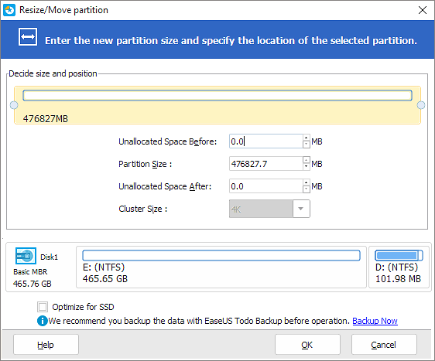
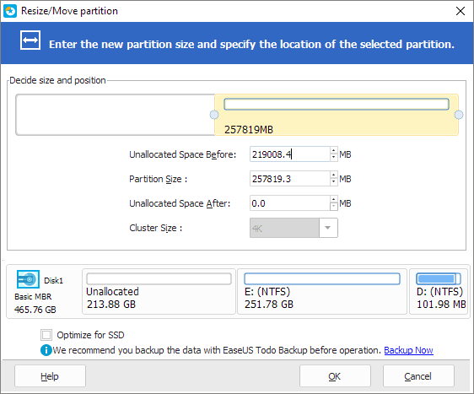
4. Now you get free space right behind system partition (C drive). Position the mouse pointer on the right partition handle. Drag the handle to cover all free space until the handle can't move when the mouse pointer changes to a double-headed arrow.
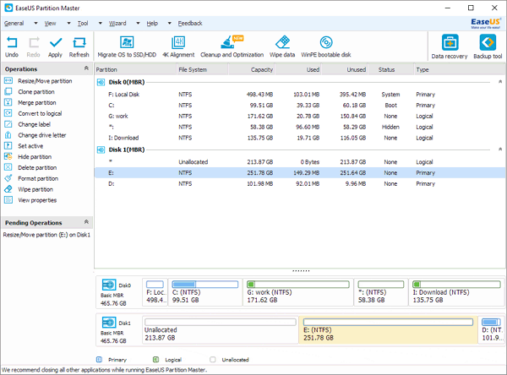
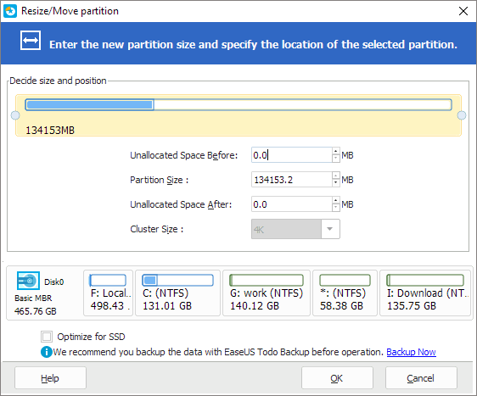
Tips: Sometime the unallocated space is on the left of the partition you want to extend, just drag the left partition handle leftwards to the size you expect.
5. Just click "Apply" and you get massage for restart. After restart you see the magic.

